District/Administrative Goals  for Student Success:  Families and Students are invited and encouraged to attend all school events (parent/teacher conferences, sports events, dance/drama/band performances, school dances, etc) in support of the Summerville Union High School District. In addition, parents are invited to participate in school decision-making through Parent Teacher Student Association and School Site Council. Each of these family-based groups plays an important and active role in planning, implementing and evaluating school-based coordinated programs.  Please read the Summerville Union High School Handbook and visit the summbears.k12.ca.us website with important reminders about upcoming school activities. We will also communicate with families through our School Reach automated phone system.  Students at Cold Springs High in  Mrs. Dyer's classes:  - Believe they can learn and will learn.  - Know and follow the school and class rules.  - Respect their school, classmates, staff, and family.  - Ask for help when needed.  - Know they are in a safe and judge free zone at all times.  - Regularly talk to guardian, parent, or trusted adult and teachers about progress in their classes.  - Participate in class and not interrupt the learning of others.  - Be responsible for their belongings and come to class prepared. | Long Barn/Cold Springs High Schools  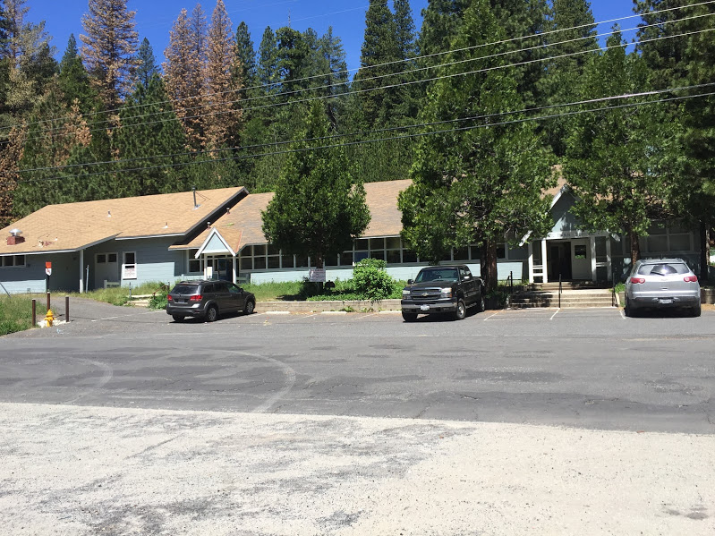  Mrs. Dyer, English and Social Sciences  ddyer@summbears.net  http://coldspringshighschooldyer.weebly.com  Cold Springs High School  25910 Long Barn Rd  Long Barn, CA 95355  (209)586-3011  Summerville Union High School District  (209) 928-4228  Attendance Office: ext. 223  www.summbears.k12.ca.us  At Cold Springs High  Mrs. Dyer's Classes:  - Endeavor to motivate students to learn.  - Teach and involve students in classes that are interesting and challenging.  - Enforce rules equitably and involve students in creating a warm and caring learning environment in the class.  - Communicate regularly with families about their child's progress in school.  - Provide assistance to families on what they can do to support their child's learning.  - Respect the school, staff, students, and families.  - Provide high-quality, standards-based curriculum and instruction.  - Communicate high expectations for every student.  - Participate in professional development opportunities that improve teaching and learning and support the formation of partnerships with families and the community.  - Have fun, listen and respect her students and families.  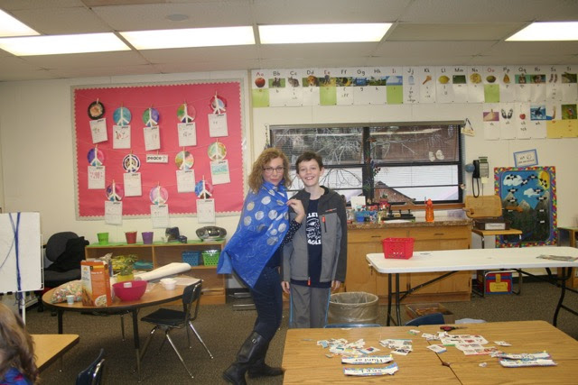 | 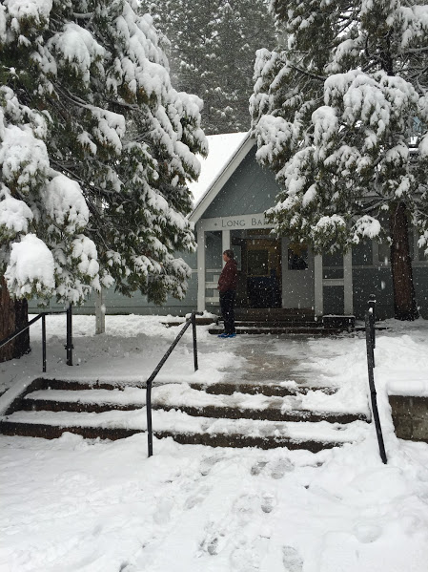  Cold Springs High School  Summerville Union High School District  SCHOOL-PARENT-STUDENT COMPACT  FOR ACHIEVEMENT  2016-2017  Our school philosophy, as an alternative school, is that families, students, and school staff should work in partnership to help each student reach his/her potential.  Summerville Union High School District’s Mission is “Committed to excellence through innovative teaching and learning. Inspiring and empowering all students by providing the tools they need to be prepared for their future in an ever changing world.”  The school-home compact is a written agreement between administrators, teachers, parents, and students. It is a document that clarifies what families and schools can do to help children reach high academic standards.  Cold Springs High Parents/Guardians Pledge to…  - Let the teacher know if my child has any problems with learning.  - Use resources the school sends home to help my child.  - Help my child see how education is relevant in the pursuit of his/her interests and goals.  - Assure that my child gets 8 hours of rest a night.  - Assure my child attends school regularly.  - Provide an area for my child to complete homework without distractions.  - Support my child and the school by letting my child attend school events, such as field trips.  - Use the PowerSchool system to stay up to date with my child’s grades and attendance.  - Make sure my child attends school ready to learn without distractions from home.  